PART 1 : GETTING STARTED DATA ANALYSIS
First of all, we loaded pandas in vs code :
pip install pandas

And then we imported pandas:
import pandas as pd

Now we can study on pandas.
To open cvf files;
df = pd.read_csv(“ file_name “ )
df = pd.read_csv("/Users/kenantufankurt/Desktop/stack-overflow-developer-survey-2019/survey_results_public.csv")
I wrote here file path to load this file as csv.

DATAFRAMES
Dataframs basically just rows and columns of data. We can see what a data frame looks like but just by printing it out. This is great thing to use jupyter nootebook because it allows us to visualize these things in ways that we cannot do in other editors.
df

We can see whole datafram by coding just the name of our data. This one print out our dataframe here. Here is some part of our data as an example:
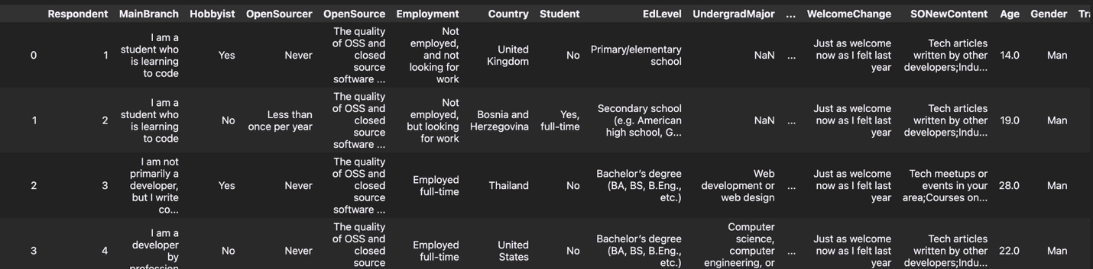
We can only see just 20 colunms in jupyter. This is about settings. When we write :
pd.get_option("display.max_columns") it says 20. It is generally like that. If we want to see all columns ;
pd.set_option("display.max_columns", None) wre can write this one. But we don’t do that because this might affect performance and screen might be complicated.
So, by default jupyter just shows 20 columns. But how can we know we have 85 columns here ?
We have shape attribute. Shape gives us the number of rows and columns in a tuple form.
df.shape
(88883, 85)
It shows us how many columns and rows we have in our data frame in tuple form.
❗️❗️Shape is an attribute it is not method that’s wyh we don’t use paranthesis:
df.shape()

If we want to have more information, we can use INFO () METHOD. This method give us number of columns and rows, alsa all of data types of all the columns as well.
df.info()
because of this is a method we use with paranthesises. df.info( )
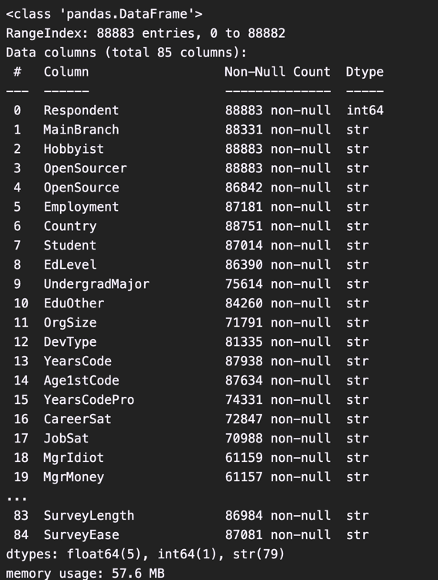
here to see off all our columns we are gonna write:
pd.set_option(‘display_max_columns’ , 85)
now we can see all 85 columns in the output.
Now we are gonna load another file:
schema_df = pd.read_csv('/Users/kenantufankurt/Desktop/survey_results_schema.csv')

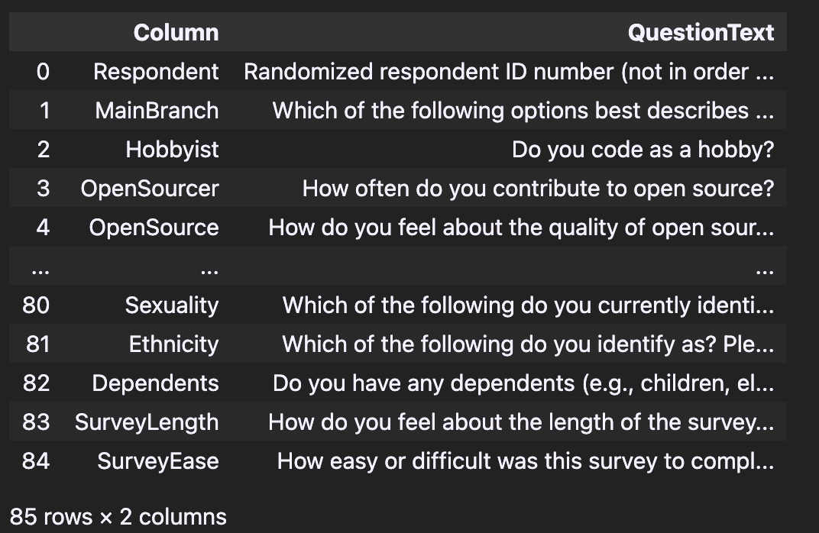

In the picture if we want to see full text we are gonna change and option or we could just access values directly we are gonan do later.
We have normally 85 columns bu here we cannot see every column. We just see here first five and last five. Let’s set this up so we can see 85 rows then reprint this.

pd.set_option('display.max_rows' , 85)
schema_df

if we just want to see first five rows we can use head ( ) method.
df.head()
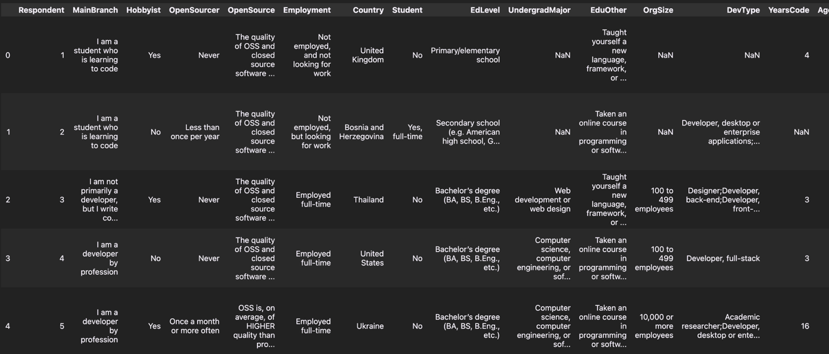

schema_df.head()

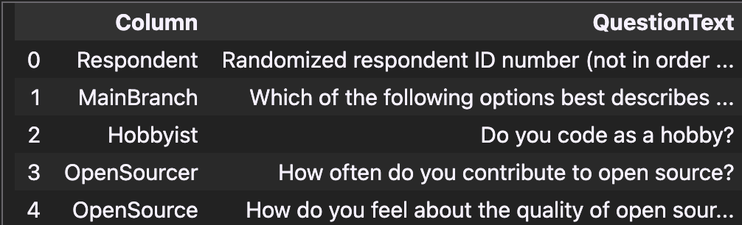

Head () method shows fisrt five rows as default. If we want to see first 10 rows:
schema_df.head(10)

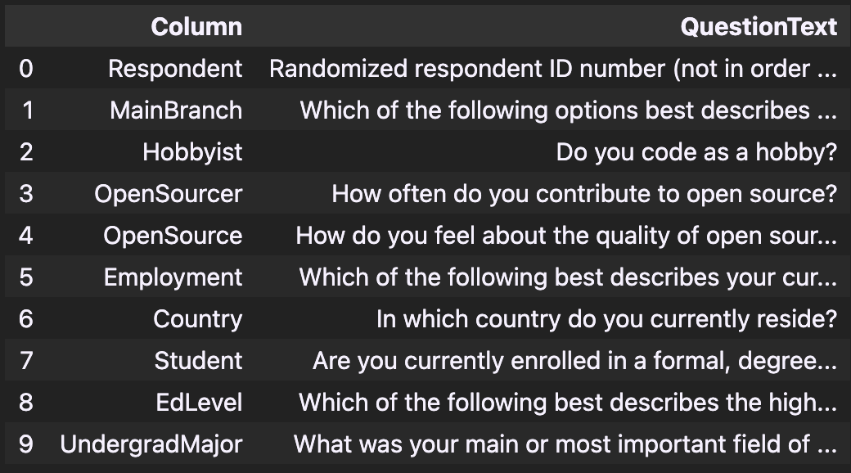
If we want to see last 5 rows we can use tail( ) method.
schema_df.tail()

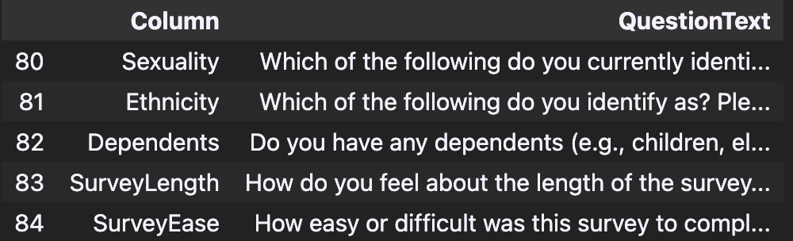
For last 10 rows:
schema_df.tail(10)

